Konfigurácie pre CCNA
Základná konfigurácia smerovača:

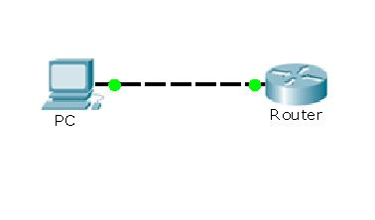
autostart = True

[localhost]

[[3640]]
image = /opt/cisco/images/c3640-ik9o3s-mz.124-7.bin
ram = 128
rom = 4
nvram = 128
idlepc = 0x60493564

[[ROUTER R1]]
model = 3640
console = 2001
slot0 = NM-1FE-TX
f0/0 = host1

Možnosť otestovať základné príkazy na konfiguráciu smerovača, zoznámenie sa s používateľskými módmi, nastavovanie mena smerovača a hesiel, základná konfigurácia rozhraní.
===================================================================

Statické a dynamické smerovanie:
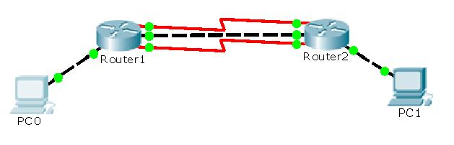
autostart = True

[localhost]

[[3640]]
image = /opt/cisco/images/c3640-ik9o3s-mz.124-7.bin
ram = 128
rom = 4
nvram = 128
idlepc = 0x60493564

[[ROUTER Router1]]
model = 3640
f0/0 = host_PC0
f1/0 = Router2 f1/0
s2/0 = Router2 s2/0
s2/1 = Router2 s2/01

[[ROUTER Router2]]
model = 3640
f0/0 = host_PC1

- Pokročilá konfigurácia rozhraní (ethernet + serial), statické smerovanie a jednoduché dynamické smerovanie.
- Možnosť otestovať záložnú linku v prípade zlyhania primárnej linky, či už sériovú, alebo ethernetovú.
===================================================================

Pokročilé smerovanie:
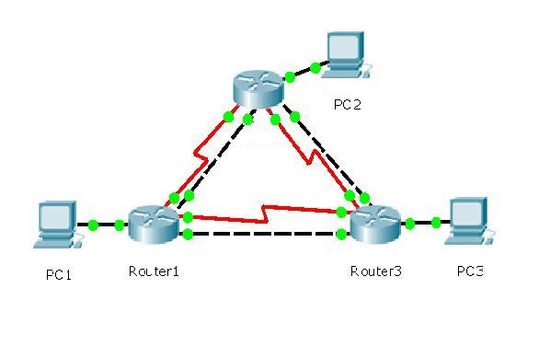
autostart = True

[localhost]

[[3640]]
image = /opt/cisco/images/c3640-ik9o3s-mz.124-7.bin
ram = 128
rom = 4
nvram = 128
idlepc = 0x60493564

[[ROUTER ROUTER1]]
model = 3640

slot0 = NM-1FE-TX
f0/0 = host_PC1
slot1 = NM-1FE-TX
f1/0 = ROUTER2 f0/0
slot2 = NM-1FE-TX
f2/0 = ROUTER3 f2/0
slot3 = NM-4T
s3/0 = ROUTER2 s3/0
s3/1 = ROUTER3 s3/1

[[ROUTER ROUTER2]]
model = 3640

slot0 = NM-1FE-TX
f0/0 = ROUTER1 f1/0
slot1 = NM-1FE-TX
f1/0 = ROUTER3 f0/0
slot2 = NM-1FE-TX
f2/0 = host_PC2
slot3 = NM-4T
s3/0 = ROUTER1 s3/0
s3/1 = ROUTER3 s3/0

[[ROUTER ROUTER3]]
model = 3640

slot0 = NM-1FE-TX
f0/0 = ROUTER2 f1/0
slot1 = NM-1FE-TX
f1/0 = host_PC3
slot2 = NM-1FE-TX
f2/0 = ROUTER1 f2/0
slot3 = NM-4T
s3/0 = ROUTER2 s3/1
s3/1 = ROUTER1 s3/1

- Pokročilá konfigurácia smerovacích protokolov OSPF, EIGRP, ale aj ich kombinácia spolu so statickými linkami a pozorovanie ako sa sieť správa.
===================================================================
BGP a iné smerovacie protokoly:
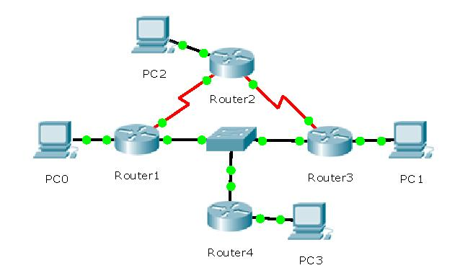

autostart = True

[localhost]

[[3640]]
image = /opt/cisco/images/c3640-ik9o3s-mz.124-7.bin
ram = 128
rom = 4
nvram = 128
idlepc = 0x60493564

[[ROUTER ROUTER1]]
model = 3640

slot0 = NM-4T
s0/0 = ROUTER2 s0/0
slot1 = NM-1FE-TX
f1/0 = SW0 1
slot2 = NM-1FE-TX
f2/0 = host_PC0

[[ROUTER ROUTER2]]
model = 3640

slot0 = NM-4T
s0/0 = ROUTER1 s0/0
s0/1 = ROUTER3 s0/0
slot1 = NM-1FE-TX
f1/0 = host_PC2

[[ROUTER ROUTER3]]
model = 3640

slot0 = NM-4T
s0/0 = ROUTER2 s0/1
slot1 = NM-1FE-TX
f1/0 = SW0 2
slot2 = NM-1FE-TX
f2/= host_PC1

[[ROUTER ROUTER4]]
model = 3640

slot0 = NM-1FE-TX
f0/0 = SW0 3
slot1 = NM-1FE-TX
f1/0 = host_PC3

[[ETHSW SW0]]
1 = access 1
2 = access 1
3 = access 1

- Testovanie smerovania medzi sieťami pomocou protokolu BGP a jeho kombinácia s inými protokolmi v rámci siete.
===================================================================

Smerovanie v zložitej sieťovej topológií:
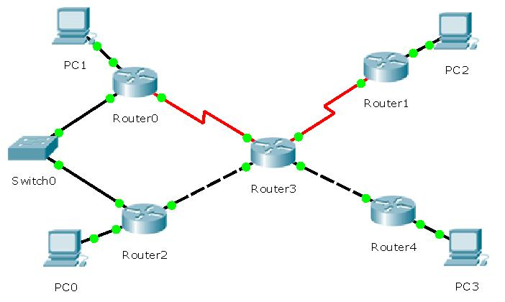

autostart = True

[localhost]

[[3640]]
image = /opt/cisco/images/c3640-ik9o3s-mz.124-7.bin
ram = 128
rom = 4
nvram = 128
idlepc = 0x60493564

[[ROUTER ROUTER0]]
model = 3640

slot0 = NM-4T
s0/0 = ROUTER3 s0/0
slot1 = NM-1FE-TX
f1/0 = host_PC1
slot2 = NM-1FE-TX
f2/0 = SW1 1

[[ROUTER ROUTER1]]
model = 3640

slot0 = NM-4T
s0/0 = ROUTER3 s0/1
slot1 = NM-1FE-TX
f1/0 = host_PC2

[[ROUTER ROUTER2]]
model = 3640

slot0 = NM-1FE-TX
f0/0 = host_PC0
slot1 = NM-1FE-TX
f1/0 = ROUTER3 f2/0
slot2 = NM-1FE-TX
f2/0 = SW1 2

[[ROUTER ROUTER3]]
model = 3640

slot0 = NM-4T
s0/0 = ROUTER0 s0/0
s0/1 = ROUTER1 s0/0
slot1 = NM-1FE-TX
f1/0 = ROUTER4 f1/0
slot2 = NM-1FE-TX
f2/0 = ROUTER2 f1/0

[[ROUTER ROUTER4]]
model = 3640

slot0 = NM-1FE-TX
f0/0 = host_PC3
slot1 = NM-1FE-TX
f1/0 = ROUTER3 f1/0

[[ETHSW SW1]]
1 = access 1
2 = access 1

- Testovanie smerovania v zložitej sieťovej topológií, odhaľovanie chýb a ich riešnie.

