http://www.weather.com/
http://www.weather.com/outlook/travel/businesstraveler/local/LOXX0001?lswe=bratislava&from=searchbox_localwx

<FORM ACTION="http://www.weather.com/search/enhancedlocalsearch" METHOD="get" NAME="whatwhere" onSubmit="return preCheckForm();">
<INPUT TYPE="hidden" NAME="whatprefs" VALUE="">
<INPUT TYPE="hidden" NAME="what" VALUE="WeatherLocalUndeclared">
<INPUT TYPE="hidden" NAME="lswe">
<INPUT TYPE="hidden" NAME="lswa">
<INPUT TYPE="hidden" NAME="from" VALUE="searchbox_localwx">
<input type="Text" class="googleGoKeywords" name="where" id="whatwhereForm2" value="Enter ZIP or US / world city" onclick="preFormInputHeader();" onKeyPress="MyLocationClose('whatwhere')" autocomplete="off">

http://rss.weather.com/weather/rss/local/LOXX0001?cm_ven=LWO&cm_cat=rss&par=LWO_rss

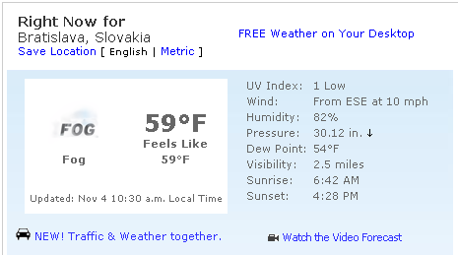

- Prepínanie medzi anglickou a metrickou sústavou cez javascript
- Čas východu a západu slnka
- Predpoveď na ďaľšie dni

http://news.bbc.co.uk/weather/
http://news.bbc.co.uk/weather/forecast/2122?search=_bratislava&region=world

<form method="get" action="/weather/forecast/10209/Search.xhtml">
<input type="hidden" name="loc" value="10209"/>
<input type="hidden" name="node" value="Search.xhtml"/>
<input type="text" class="text" name="search" id="weathersearch"/> <input id="submitbutton_search" class="submitbut" type="submit" value="SEARCH" />

http://feeds.bbc.co.uk/weather/feeds/rss/5day/world/4129.xml

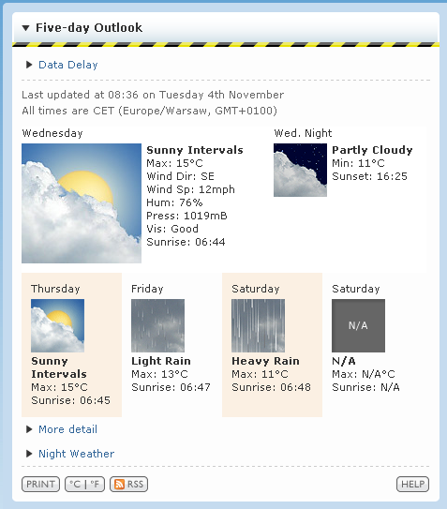

- Len základné údaje
- Čas východu a západu slnka
- Predpoveď na ďaľšie dni

http://weather.yahoo.com/
http://weather.yahoo.com/Bratislava-Slovakia/LOXX0001/forecast.html

<form name="pform" id="pform" action="/search/weather2" method="post">
<input type="textbox" value="" autocomplete="off" id="ptrigger2" name="ptrigger2"/><a onclick="return false;" href="#formarrow" id="ptrigger3">
<input type="submit" value="Go" id="psubmit2"/>

http://weather.yahooapis.com/forecastrss?p=LOXX0001&u=f

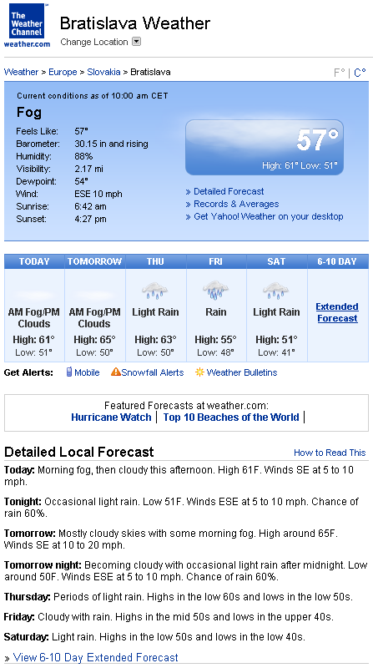

- Čas východu a západu slnka
- Predpoveď na ďaľšie dni
- Textový popis počasia

http://www.wunderground.com/
http://www.wunderground.com/cgi-bin/findweather/getForecast?query=bratislava&wuSelect=WEATHER
<form action="/cgi-bin/findweather/hdfForecast" name="wxsearch">
<input type="text" name="query" value="" onfocus="if(this.value==wui_search_value)this.value='';this.className='focused'" class="unfocus" id="wuSearch" onchange="wui_search_changed=1;" onblur="wui_search_changed=1;"/>
<input type="submit" value="Go" id="wuSubmit" onclick="SubmitFastForecastSearch(); return false;" />

http://rss.wunderground.com/auto/rss_full/global/stations/11816.xml?units=both

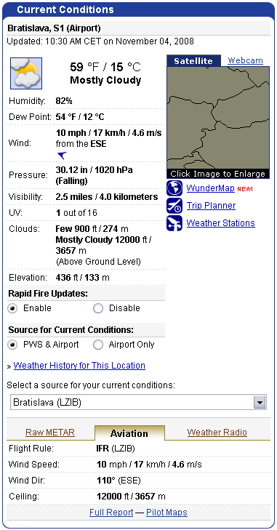

- Údaje v anglickej aj metrickej sústave priamo na stránke
- História počasia

http://www.theweathernetwork.com/
http://www.theweathernetwork.com/weather/loxx0001

<form id="searchform" name="searchform" action="index.php" method="get" onsubmit="javascript:return checksearchformEn(document.searchform.prodname.value);">
<input type="hidden" name="product" id="product" value="search" />
<input type="hidden" name="pagecontent" id="pagecontent" value="results" />
<input type="hidden" name="searchterm" id="searchterm" value="" />
<input type="hidden" name="prodtype" id="prodtype" value="" />
<input type="text" class="textbox" id="searchbox" name="prodname" value="Search for Location" onclick="cookieavail(); " onkeypress="document.getElementById('mylocations').style.display='none';" onblur="checkWhitespace();" />

http://rss.theweathernetwork.com/weather/loxx0001

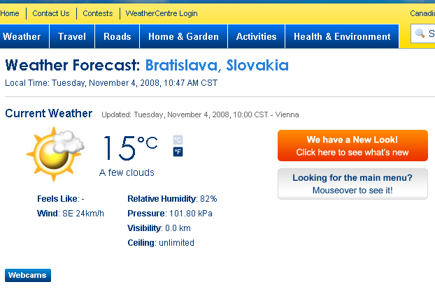

- Prepínanie medzi anglickou a metrickou sústavou pomocou GET parametra
- Základné údaje
- Predpoveď na ďaľšie dni

